Multiple Intelligences MAVO/HAVO/VWO
You could say that homo universalis Leonardo Da Vinci was smart or intelligent in more than one way. He was good at maths, physics (science) and the arts. There are many theories about what intelligence is and what is not. One theory is that we all possess (=bezitten) multiple intelligences. Watch the video below about multiple intelligences.
https://youtu.be/tQHgfuziVBo

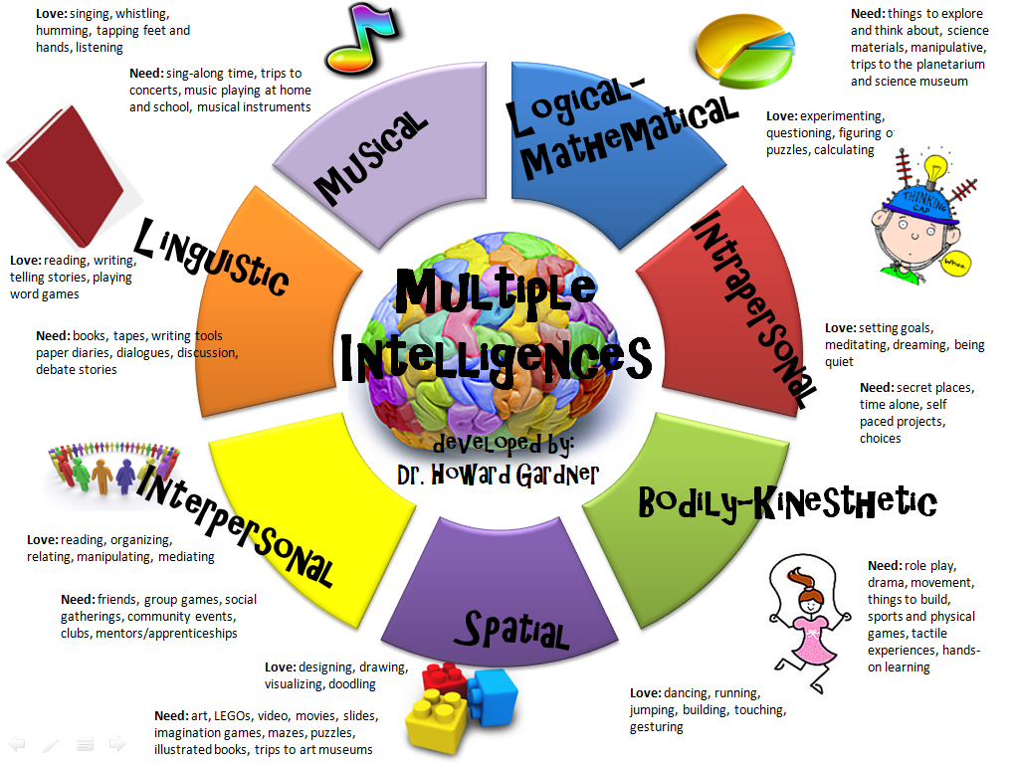
A. Match the intelligences with the correct skills in the grid below.
Intelligence | Skills
Logical-mathematical | Learning languages
Spatial –visual | Dancing
Naturalist | Playing guitar
Linguistic | Knowing what you are good at
Bodily-kinaesthetic | Packing a suitcase
Interpersonal | Caring for pets
Musical | Solving number problems
Intrapersonal | Seeing when someone is hurt

MAVO/HAVO/VWO
B. Answer the following questions in English.
- Which combination do you think you are? Give at least two examples for each.
________________________________________________________________________________________________________________________________________________________
- Ask your neighbour which intelligences he/she has. Why did they pick those?
________________________________________________________________________________________________________________________________________________________
- Which intelligences are most important to you? Give at least two arguments to support your answers.
________________________________________________________________________________________________________________________________________________________
VWO
- Which intelligences do you think are most important to society? Give at least two arguments to support you answer.
________________________________________________________________________________________________________________________________________________________
- Which intelligences would you like to be better at? Explain why.
________________________________________________________________________________________________________________________________________________________

MAVO/HAVO/VWO
Next we are going to see whether we were right about our intelligences. Go to the link below to complete the self-assessment.
https://personalitymax.com/personality-test/
Here you can complete a test to find out what intelligences apply to you personally. When you have finished the test, you get information about how the different intelligences are important to you and what this means. You also get information about your characteristics and there is a list of various jobs that might be interesting to you. In short; a lot of information to think about!
Save your information by copying the link from your browser and pasting it here:

MAVO/HAVO/VWO
C Compare and Contrast in pairs
- Compare your result from the self-assessment to your answers that you gave in task B. Are they similar (hetzelfde)?
________________________________________________________________________________________________________________________________________________________
- Why do you think they are the same/different?
________________________________________________________________________________________________________________________________________________________
- Ask your neighbour the same questions. Are their results the same or different?
________________________________________________________________________________________________________________________________________________________
- Do you think the test is right or wrong? Explain with two or more arguments why you think so. Write down your arguments.
________________________________________________________________________________________________________________________________________________________
HAVO/VWO
- Do you think it is important to know the answer to this or any intelligence test? Support you answer with two or more arguments. Write down your arguments.
________________________________________________________________________________________________________________________________________________________________________________________________________________________________________________________________________________________________________________
MAVO/HAVO/VWO
D Compare and Contrast in our class
- Let’s have a look at the results of the class.
________________________________________________________________________________________________________________________________________________________
- Are the results similar to yours?
________________________________________________________________________________________________________________________________________________________
- Is there difference between boys and girls?
________________________________________________________________________________________________________________________________________________________
- Is this right or wrong? What do you think?
________________________________________________________________________________________________________________________________________________________
- Does it make a difference if it is or isn’t right?
________________________________________________________________________________________________________________________________________________________
- Have we learned anything from the test?
________________________________________________________________________________________________________________________________________________________
- Are we going to change anything about our behaviour, way of learning or future?
________________________________________________________________________________________________________________________________________________________
